Homework Assignment 08

Name: Asrar Syed
Due by: April 22, 2026
Course Section: CSC 4330-002

- The composition of Figure 2 has 6 states — how many traces does it have?

“each path from the initial state ⟨0, 0⟩ to the final state ⟨1, 2⟩ represents a possible trace of this system, e.g., think → drink coffee → talk.”

In figure 2, there is at 3 total traces of this system:
Trace 1: start drink coffee think talk
{0, 0} {1, 0} {1, 1} {1, 2}

Trace 2: start think drink coffee talk
{0, 0} {0, 1} {1, 1} {1, 2}

Trace 3: start think talk drink cofee
{0, 0} {0, 1} {0, 2} {1, 2}

- Suppose we were to add a third (concurrent) process of “eat cookie” to our situation, as depicted in Figure 3 — draw out the resulting composition of the three concurrent processes “drink coffee”, “think → talk” and “eat cookie” (you may do this on paper and take a picture).

We have three concurrent processes:

Coffee: 0 1 (drink coffee)
Conversation: 0 1 2 (think talk)
Cookie: 0 1 (eat cookie)

Each global state becomes a triple: ⟨c,t,k⟩

Where:
c ∈ {0,1}: coffee
t ∈ {0,1,2}: think/talk
k ∈ {0,1}: cookie

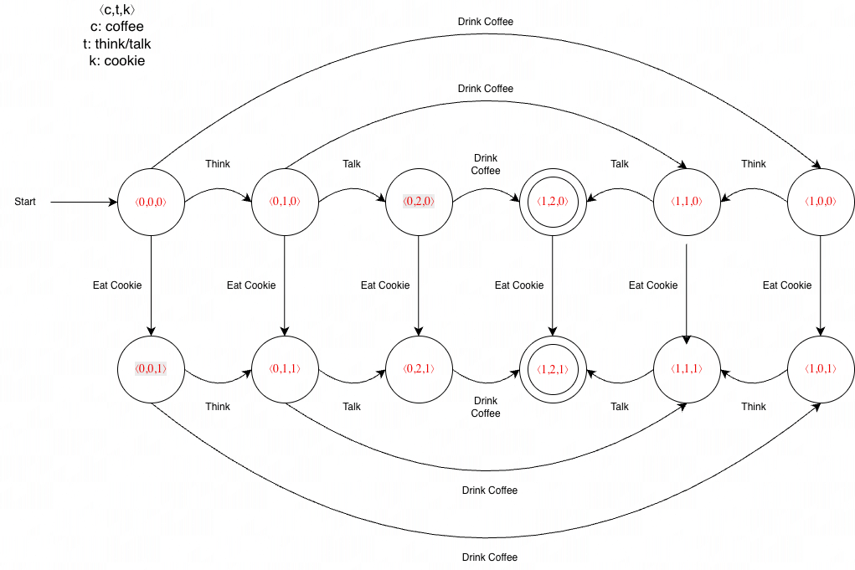

- How many states does the composition of (2.) have?

Each component is independent, so total states: 2*3*2=12
So, 12 total states

We take every Figure 2 state and pair it with:

k = 0 (haven’t eaten cookie)
k = 1 (have eaten cookie)
All 12 states:

Cookie = 0 layer:

⟨0,0,0⟩ (start)
⟨1,0,0⟩
⟨0,1,0⟩
⟨1,1,0⟩
⟨0,2,0⟩
⟨1,2,0⟩

Cookie = 1 layer:

⟨0,0,1⟩
⟨1,0,1⟩
⟨0,1,1⟩
⟨1,1,1⟩
⟨0,2,1⟩
⟨1,2,1⟩ (final)

- How many traces does it have?

There is also 12 traces in total, a trace being a path from ⟨0,0,0⟩ (start) to ⟨1,2,1⟩ (final)

- In the above, we had the three concurrent processes p_1, p_2 and p_3, each with the number s_1 = 2, s_2 = 3 and s_3 = 2 of states, respectively.

In general, for a set of n concurrent processes p_1, p_2, . . . p_n, each with the number s_1, s_2, …, s_n of states, respectively, how many (composite) states would the composition of these n processes have?

Each process p_i can independently be in one of s_i states. A composite state is formed by choosing one state from each process.

So the total number of composite states is simply the number of all possible combinations:

$$s_{1}×s_{2}×…s_{n}=\prod_{i=1}^{n}{s_{i}}$$

- Model this situation of three concurrent processes with Java threads, in a similar way as that of running several countdown timers concurrently^1. That is, the “drink coffee” process will pause for a bit, then simply output “drink coffee” and exit (the “eat cookie” process will be similar), while the “think → talk” process will pause for a bit, output “think”, pause for another bit, then output “talk” and exit. You may reuse the countdown timer code of footnote 1 for your purposes — it will behave analogously, in that your code will output sequences like: drink coffee → think → eat cookie → talk, i.e., traces of the composition of (2.)

Added code files.
